**Generative AI Use Statement**

**Class No.: 28**

**Name: Chen Kai**

**Part 1 Disclosure Statement: Please check all boxes that apply.**

I did not use generative AI tools in creating this paper. 🞏

or

I did use generative AI tools in creating this paper, namely ________Google Gemini_________________ (*ChatGPT*, *Grammarly*, *Google Translate*, etc.). I used it in the following ways (check which of the following acceptable uses were utilized):

* Brainstorming 🞏
* Generating ideas/topics/research questions 🞏
* Outlining help 🞏
* Language/grammar/spelling/punctuation/mechanics help 🗹
* Others 🞏 (Please be specific):

and

* I affirm I did not generate text with artificial intelligence and directly copy it into my paper. 🗹
* I affirm I have checked the information (e.g. evidence, examples, sources of research) provided by AI to avoid misinformation used in writing. 🗹
* I will provide a reflection on using generative AI tools in Part 2. 🗹
* I will attach screenshots of the most relevant interactions with AI in Part 3. 🗹

**Part 2 Analysis and Reflection**

1. The reasons I use AI in writing this paper include:

AI is more precise in grammar check than myself.

1. I find using AI tools has the following pros and cons:

AI is much more convenient and precise. However, I have to use complex prompts to help AI generating the things I want. Also, I have to verify the accuracy of the information and the reliability of the sources.

**Part 3 Appendix (attach screenshots and/or line-by-line comparison below)**

Please attach **the most relevant** interactions with AI in each category if it applies and provide explanations of how you use the information generated by AI in writing. You may write explanations in **Chinese**.

1. Brainstorming

**Explanation:**

1. Generating a research question

**Explanation:**

1. Outline help

**Explanation:**

1. Language/grammar/spelling/punctuation/mechanics help

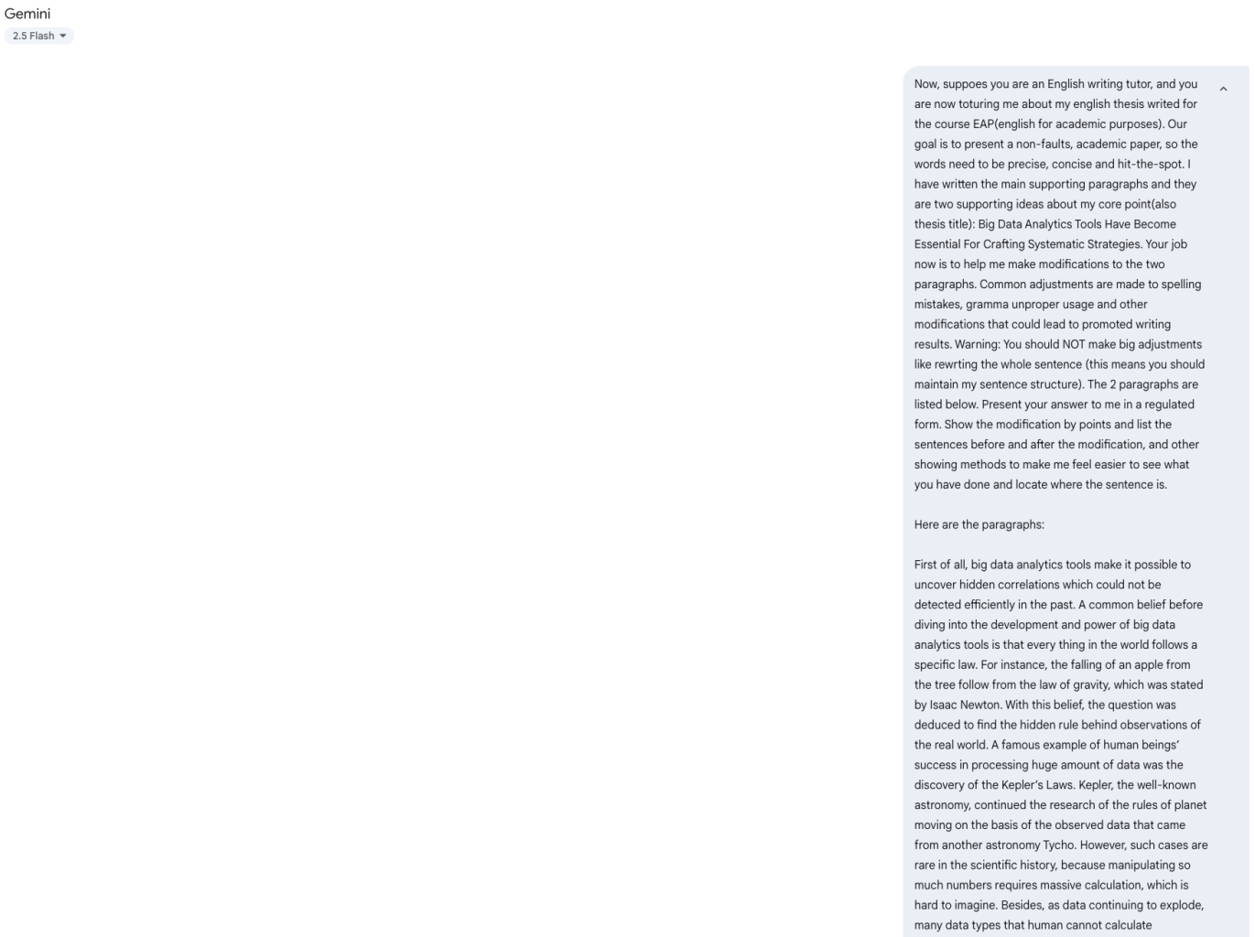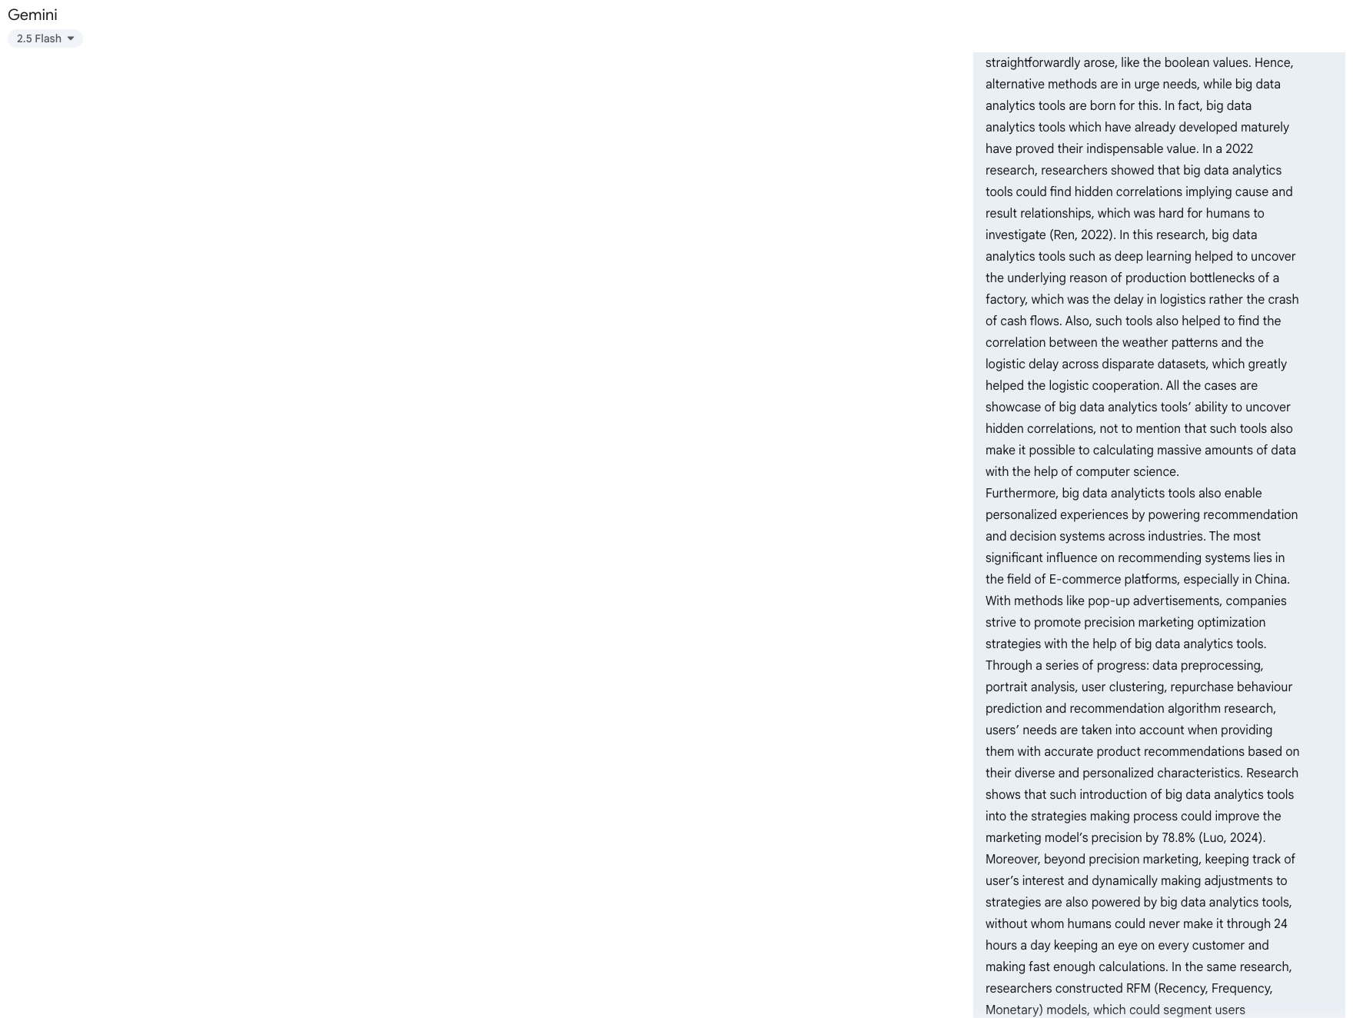

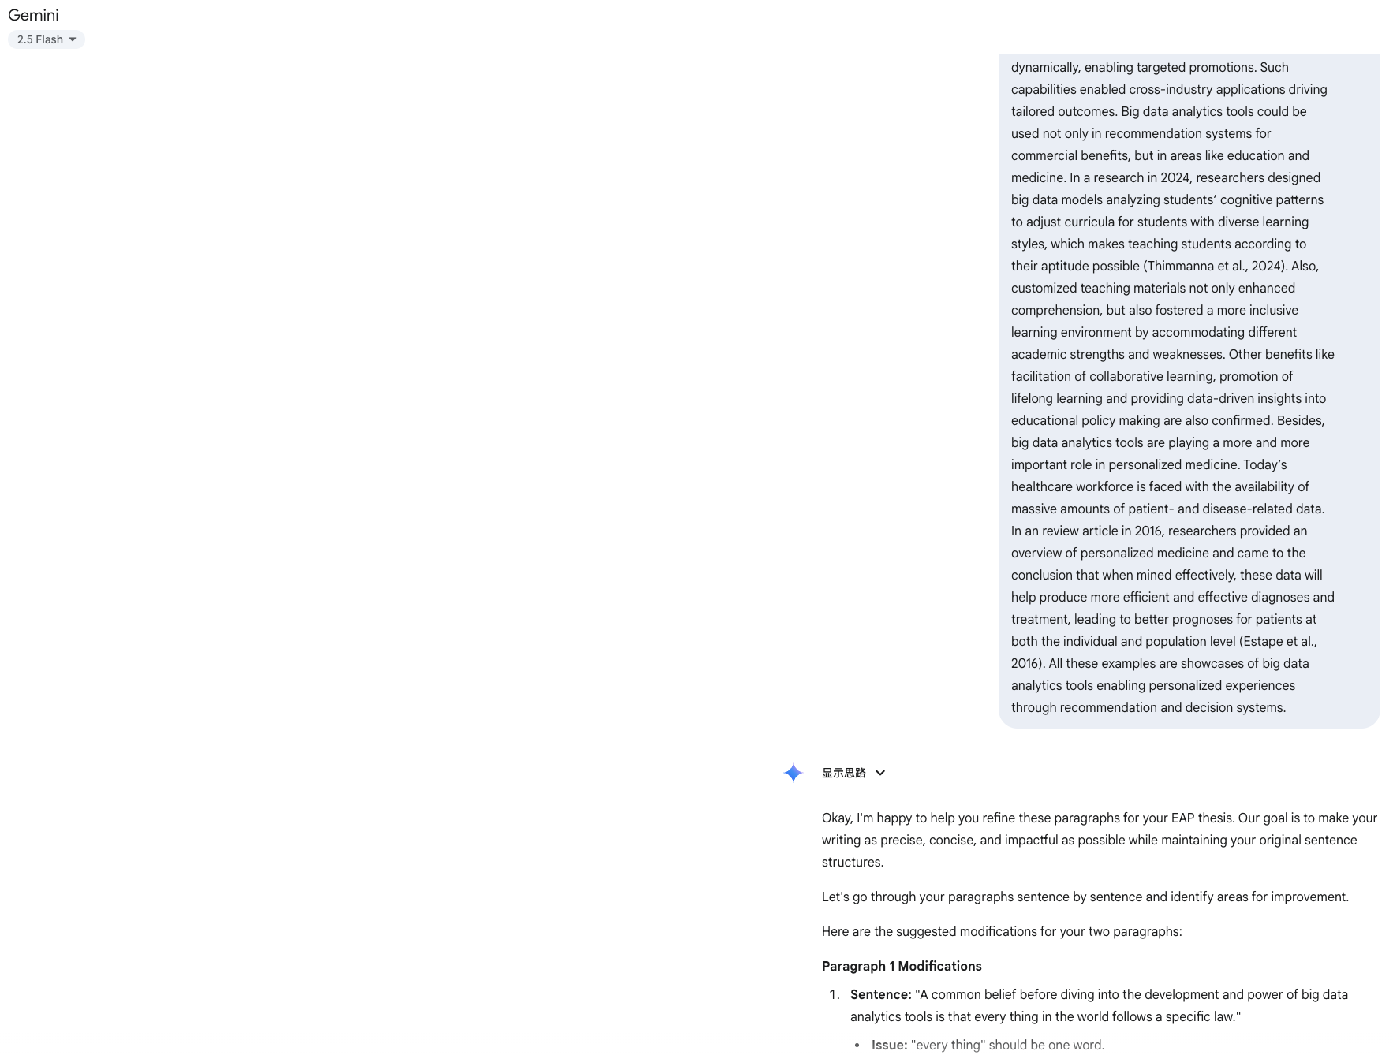

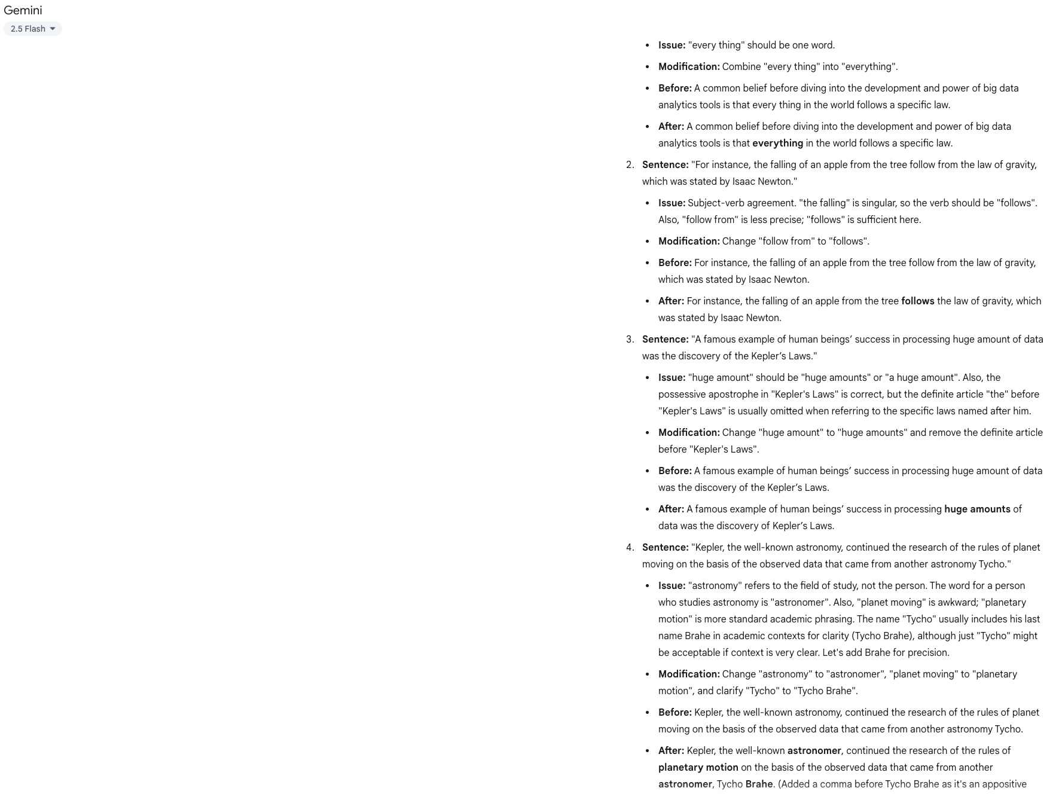

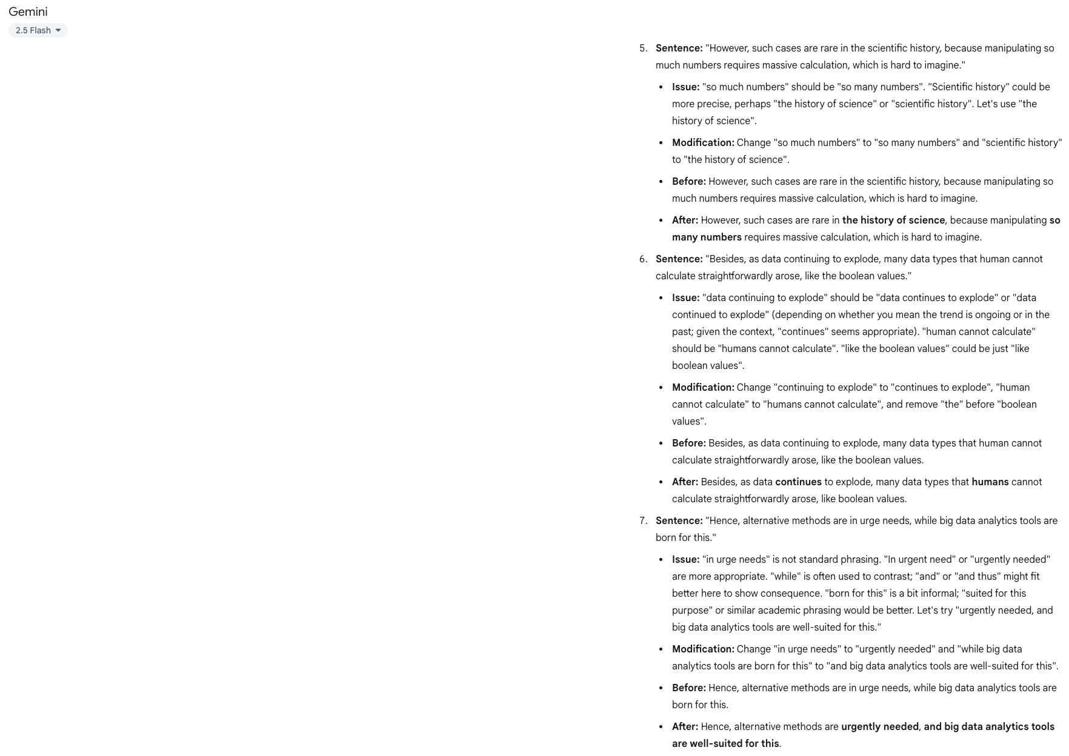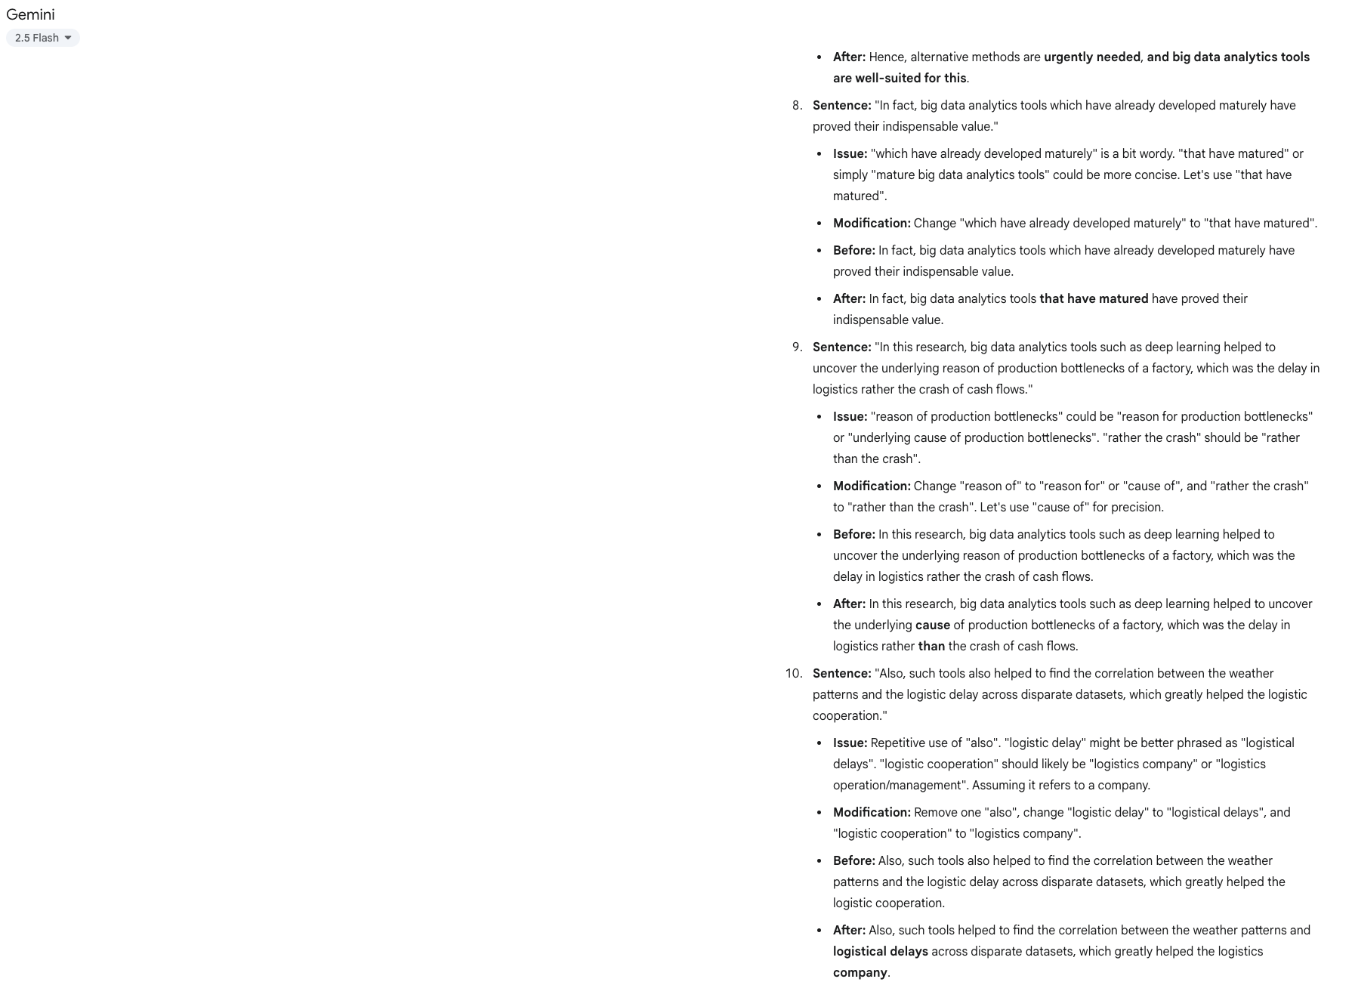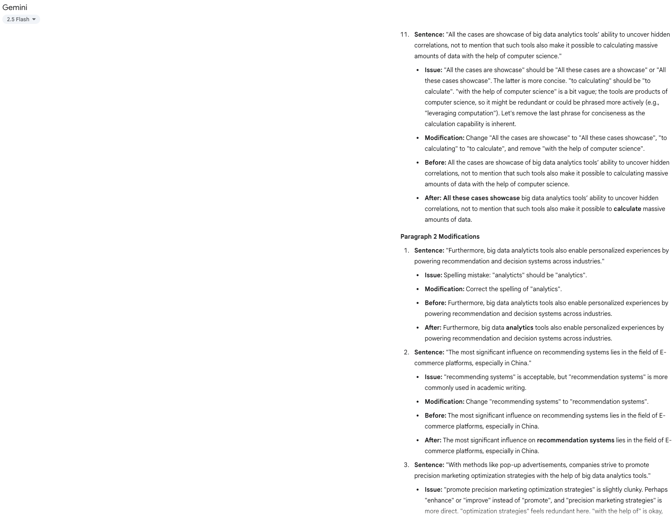

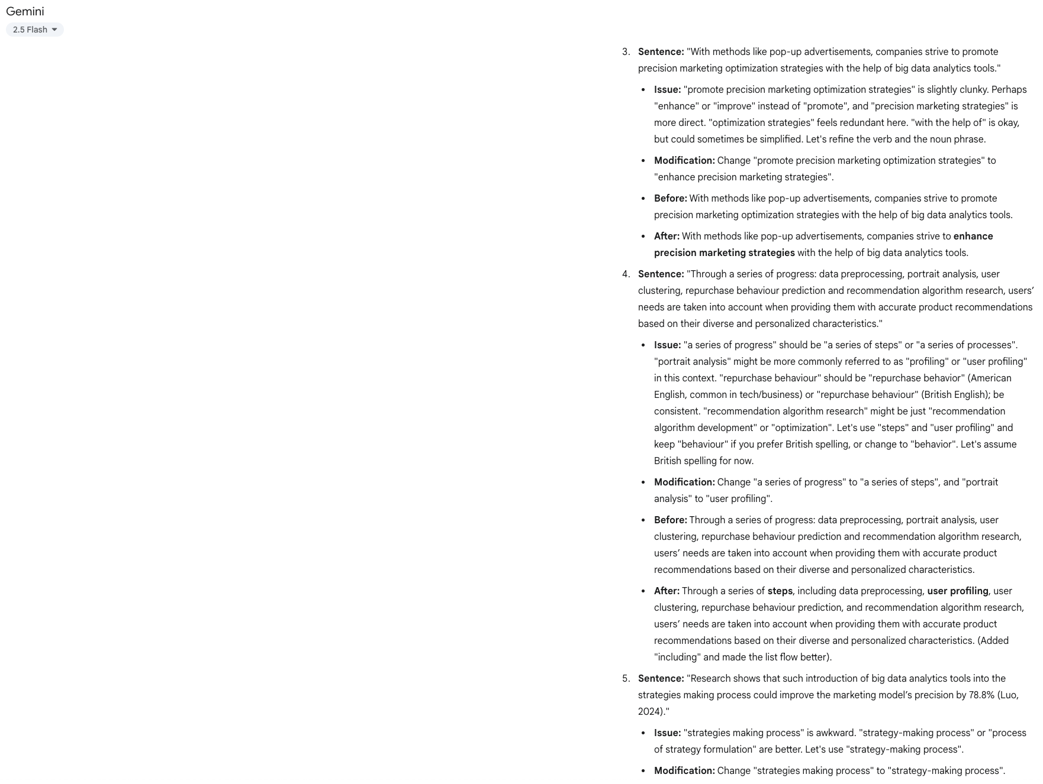

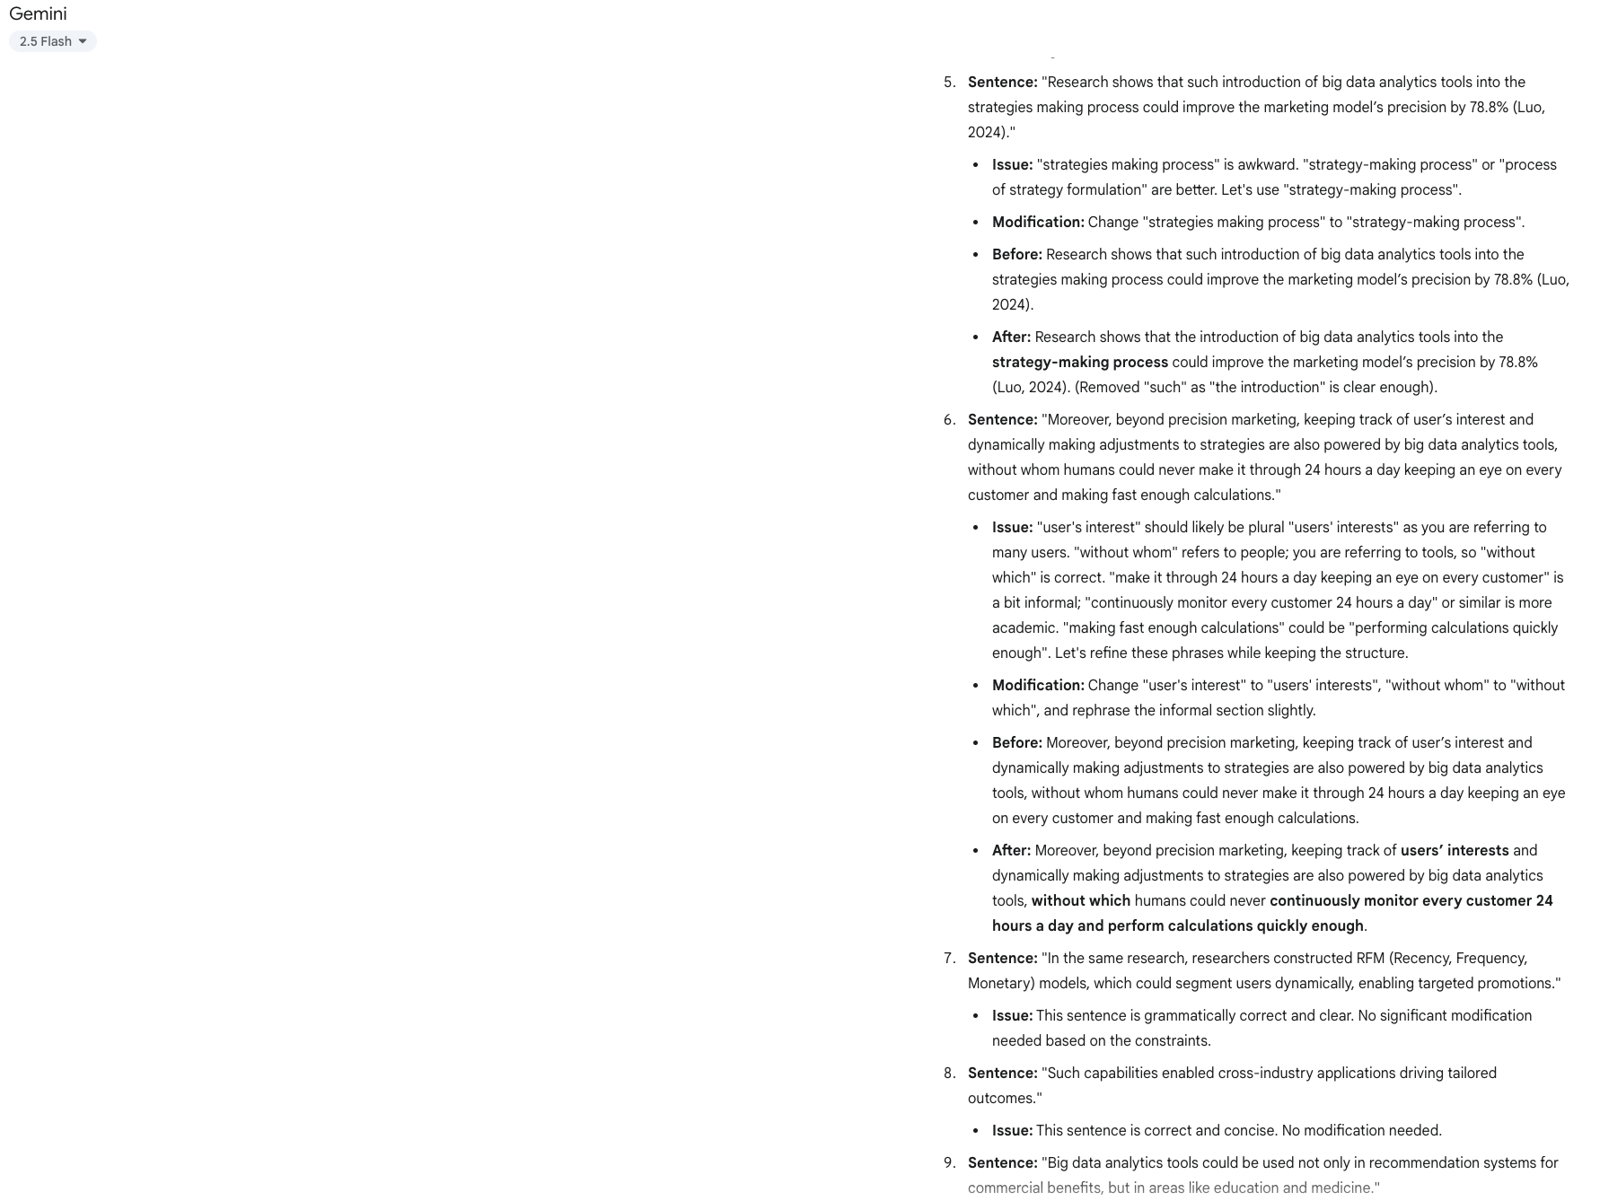

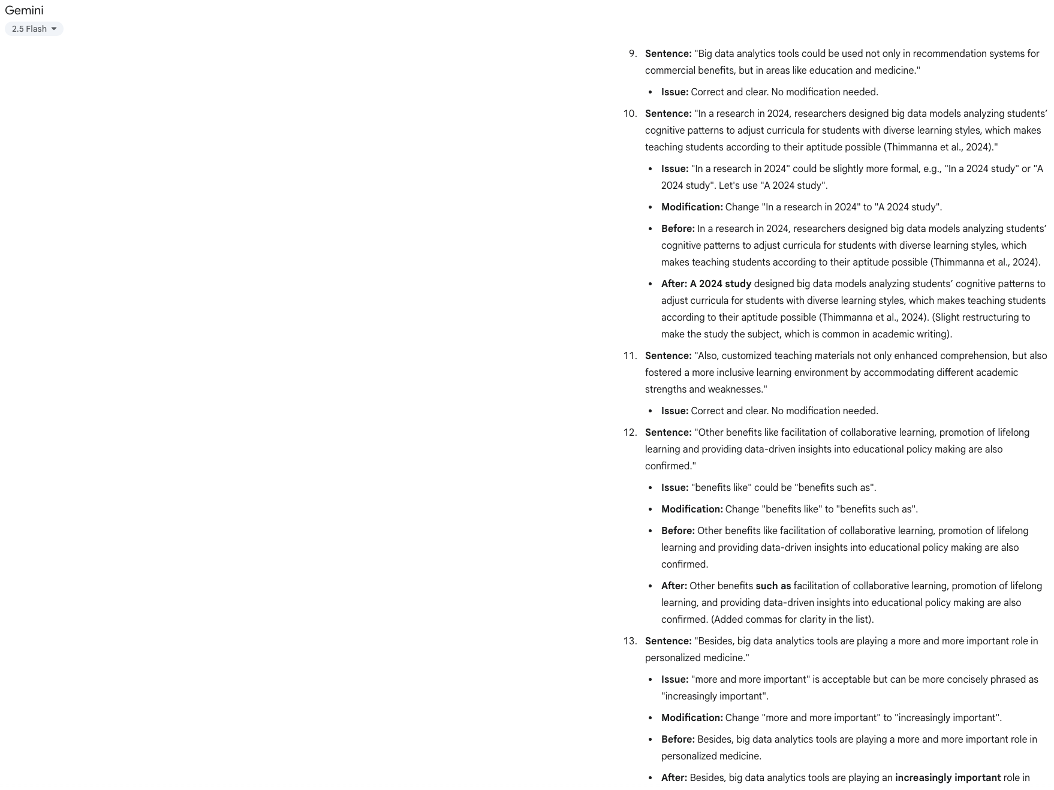

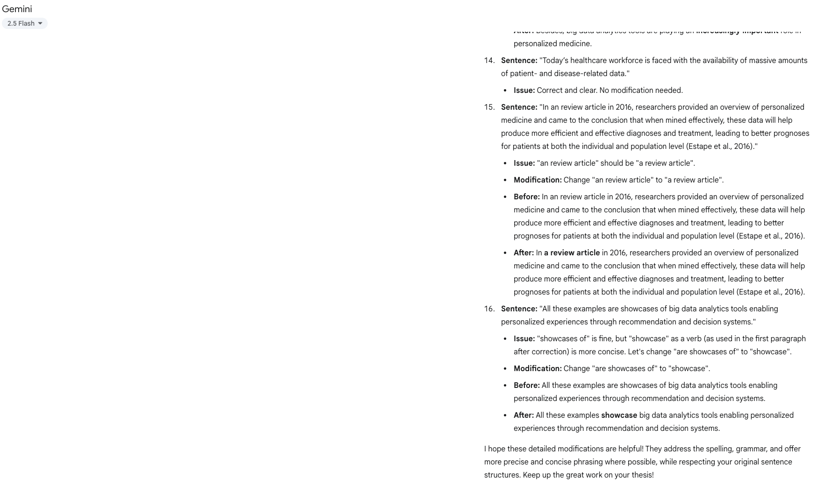

**Explanation:**

I have problems guaranteeing my paper has no grammar mistake, so I went to Google Gemini for help. However, I’m afraid of AI changing my ideas and structures. So I give a complex prompt to tell it that you should not change my sentence structures and ideas behind them. Also, for better visualization, I prompt it to give feedback in a well-listed way. After that, I carefully checked each problem it said and make corrections to my sentences accordingly.

1. Others

**Explanation:**